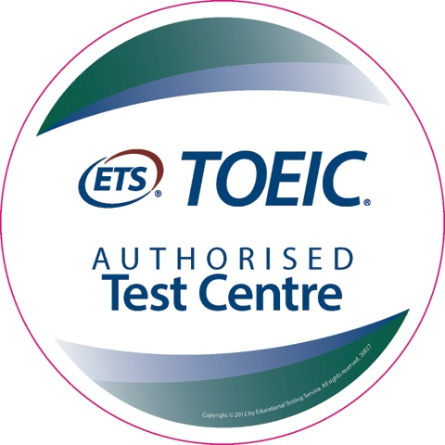
TOEIC Application Form
Listening & Reading Test (Public / Official)
http://www.toeictest.com.au

Personal Information
Family Name
Given Names
Date of Birth
Phone
Email
Nationality
Passport #
You must have a valid passport at the test session

Score Mailing or Pickup
How would you like to receive your results?
☐ local mail ($10)
☐ courier ($ extra cost)
☐ stamped, self-addressed A4 envelope (free)
☐ pickup at my local L&R Test Centre

Postal Address
Street:

Suburb:
State:
Postcode:
Country:

Payment
I would like to pay my NZ$230 test fee
☐ via Paypal / Credit Card ($5 surcharge)
☐ via direct deposit
☐ I am transferring from my local test centre
and have already paid

Test Date:
(see www.toeictest.com.au for dates)

Location
I would like to test in:

■ Engadine (Sydney)
■ Springfield (Brisbane)
■ Melbourne
■ Lautoka (Fiji)
■ Queenstown (NZ)
■ Online (note Institutional test only)

For other locations see www.toeictest.com.au

Corporate Testing:
☐ This test is required for my company
Company name:

Preparation
Read the TOEIC Examinee handbooks before the exam.

www.toeictest.com.au/handbook
You can practice a short online sample test at
www.toeictest.com.au/prepare

An online Official TOEIC Preparation Course (OLPC) is also available at a discount. This is an online English learning course and TOEIC preparation course.

The OLPC includes multiple full length practice tests.

■ Tell me more about the TOEIC OLPC
■ I wish to purchase the TOEIC OLPC for $30

If a place is available, it will be held for you, and we will send you payment instructions.
Your place will be held awaiting your payment, which must be made at least 1 week prior to the test.
It is our policy to not allow changes within 2 weeks of the test date. However, it is sometimes possible to make changes, please enquire. There is no refund for cancellation on the day of the test, or non-attendance.

