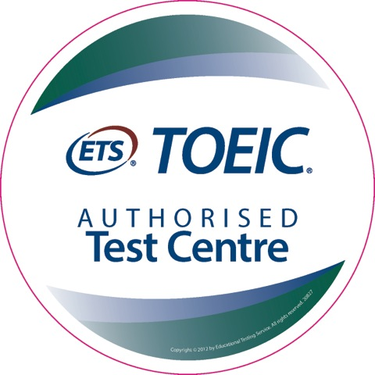
TOEIC Application Form
Speaking & Writing (S&W) Public Test
http://www.toeictest.com.au/public/engadine Engadine Test Centre

Personal Information
Family Name
Given Names
Date of Birth (dd/mm/yyyy)
Phone
Email
Nationality
Passport #
You must provide a valid passport at test sessions

Score Mailing or Pickup
How would you like to receive your results?
☐ pickup at Engadine S&W Test Centre
☐ pickup at my L&R Test Centre
☐ mail
☐ courier ($ extra cost)

Postal Address
Street:

Suburb:
State:
Postcode:
Country:

Preparation
Read the TOEIC Examinee handbooks before the exam.
S&W www.toeictest.com.au/swhandbook
L&R www.toeictest.com.au/handbook

Additionally an online TOEIC OLPC is available for Listening & Reading. Please enquire.
Test Request
Which tests would you like?
- Speaking + Listening & Reading $330 ☐
- Speaking & Writing + Listening & Reading $390 ☐

I have already paid the L&R Centre $180 ☐
please deduct $180 from my charge.

Speaking Test Date: (dd/mm/yyyy)
(see www.toeictest.com.au/speaking for dates)

Listening & Reading Test Date:
(see www.toeictest.com.au for dates and locations)

Attention Listening & Reading candidates:
The Public L&R Test is run on a different day, at a nearby centre.

Have you made an enquiry with an L&R Test centre?
■ Yes, please co-ordinate with them
■ No, please have an L&R representative contact me

L&R Test Centre contacted (or preferred location)
■ Town Hall (JET)
■ Chinatown (Big Bridge)

Corporate Testing:
☐ This test is required for my company
☐ Request corporate quote

Other Charges and Options:
- Extra L&R Official Score Certificate(s): $15 x
- Extra S&W Official Score Certificate(s): $15 x
- Decorative “Certificate of Achievement” $30 ☐
- Request price for courier ☐

If a place is available it will be held for you, and we will send you payment instructions. Your place will be held awaiting your payment, which must be made at least 1 week prior to the test.
It is our policy to not allow changes within 2 weeks of the test date. However, it is sometimes possible to make changes, please enquire. There is no refund for cancellation on the day of the test, or non-attendance.
Your signature will be required on test day, affirming that your personal information is accurate, and that you have read the TOEIC Test Examinee Handbook containing TOEIC Test policies and procedures.

